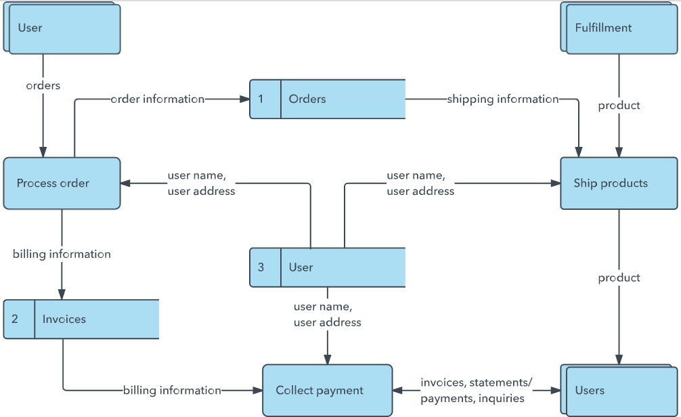

Project Design Phase-II

Data Flow Diagram & User Stories

|  |  |
| --- | --- |
| Date | 13 October 2022 |
| Team ID | **PNT2022TMID51925** |
| Project Name | Project - Customer Care Registry |
| Maximum Marks | 4 Marks |

# Data Flow Diagrams:

A Data Flow Diagram (DFD) is a traditional visual representation of the information flows within a system. A neat and clear DFD can depict the right amount of the system requirement graphically. It shows how data enters and leaves the system, what changes the information, and where data is stored.

Example: DFD Level 0 (Industry Standard)

# Example: [(Simplified)](https://developer.ibm.com/patterns/visualize-unstructured-text/)

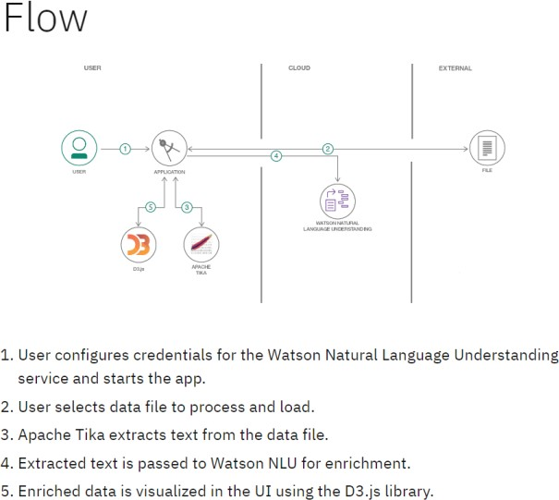

**Data flow diagram for Customer Care Registry:**

**User Stories**

|  |  |  |  |  |  |  |
| --- | --- | --- | --- | --- | --- | --- |
| **User Type** | **Functional**  **Requirement (Epic)** | **User Story Number** | **User Story / Task** | **Acceptance criteria** | **Priority** | **Release** |
| Customer (Web user) | Registration | USN-1 | As a customer, I can register for the application by entering my email, password, and confirming my password. | I can access my account / dashboard | High | Sprint-1 |
|  | Login | USN-2 | As a customer, I can login to the application by entering correct email and password | I can access my account / dashboard | High | Sprint-1 |
|  | Dashboard | USN-3 | As a customer, I can see all the tickets raised by me and lot more | I get all the info needed in my dashboard | High | Sprint-1 |
|  | Ticket creation | USN-4 | As a customer, I can create a new ticket with the detailed description of my query | I can ask my query | High | Sprint-2 |
|  | Address Column | USN-5 | As a customer, I can have conversations with the assigned agent and get my queries clarified | My queries are clarified | High | Sprint-3 |
|  | Forgot password | USN-6 | As a customer, I can reset my password by this option incase I forgot my old password | I get access to my account again | Medium | Sprint-4 |
|  | Ticket details | USN-7 | As a customer, I can see the current status of my tickets | I get better  understanding | Medium | Sprint-4 |
| Agent  (Web user) | Login | USN-1 | As an agent, I can login to the application by entering correct email and password | I can access my account / dashboard | High | Sprint-3 |
|  | Dashboard | USN-2 | As an agent, I can see all the tickets  assigned to me by the admin | I can see the tickets to  which I could answer | High | Sprint-3 |
|  | Address Column | USN-3 | As an agent, I get to have conversations with the customer and clear his/her queries | I can clarify the issues | High | Sprint-3 |
|  | Forgot password | USN-4 | As an agent, I can reset my password by this option in case I forgot my old password | I get access to my account again | Medium | Sprint-4 |
| Admin  (Web user) | Login | USN-1 | As an admin, I can login to the application by entering correct email and password | I can access my account / dashboard | High | Sprint-1 |
|  | Dashboard | USN-2 | As an admin, I can see all the tickets  raised in the entire system and lot more | I can assign agents by seeing those tickets | High | Sprint-1 |
|  | Agent creation | USN-3 | As an admin, I can create an agent for clarifying the customer’s queries | I can create agents | High | Sprint-2 |
|  | Assigning agent | USN-4 | As an admin, I can assign an agent for each ticket created by the customer | Enables agent to clarify  the queries | High | Sprint-2 |
|  | Forgot password | USN-4 | As an admin, I can reset my password by this option in case I forgot my old password | I get access to my account again | Medium | Sprint-4 |